

Faculty of Informatics and Computer Science

*Software Engineering*

**Smart gym trainer**

By: Mazen Tarek Abdelmaksoud

Supervised By

Prof. Khaled Nagaty

June **2023**

Abstract

As I was doing my gym exercises and my coach realized that I am doing it wrong, he taught me how to do it. Then, in the next exercise, the exact same thing happened. I have asked my coach if there are many people like me who may exercise in the wrong way, and he said that 80% of people make mistakes while exercising. As they also do not know if they are playing it right or wrong, as a symptom of doing an exercise wrong is that you might not feel the muscle you should be training; for example, doing squats in your lower back, you should feel the burning sensation and a good squeeze and contraction of the muscle. Other symptoms, such as pain during or after exercise, and you are not getting the expected output. Because there is nothing called doing the exercise perfectly, there is something called an acceptable form. Many people suffer from injuries because they think of exercising in the right way, but they do not. Therefore, spending so much money on a personal coach can annoy introverted people. We could replace the personal coach with an application that can help you in your exercises by standing in front of a laptop, tablet, or smartphone and getting a body skeleton, which can count for you the correct counts while you are doing the exercise, and there will be a voice-over that warns you when doing a count in an incorrect form. At the end of every set, the program will evaluate every set and determine what can be done to boost trainee performance to obtain the best exercise outcome. For example, when performing squats, the program should count when the trainee pushes his hips back and then stands up again to the normal position, while his neck and back are in one line; it should count for him one count other than this, it should not count anything and warn him to change it to the correct way.

Attestation &Turnitin Report

I understand the nature of plagiarism, and I am aware of the university’s policy on this. I certify that this report reports original work by me during my university project except for the following



Signature: Mazen Tarek Date: 10/6/2023

Acknowledgements

I would like to take the opportunity to thank my mentor, Prof. Khaled Nagaty, for the time and effort during the semester. I genuinely appreciate the helpful tips and guidance that was provided. I am grateful to you.

List of Abbreviations

|  |  |
| --- | --- |
| **Abbreviation** | **Definition** |
| ROM | Range Of Motion |
| AP | Average Precision |
| IoU | Intersection over Union |
| HPE | Human Pose Estimation |
| 2D HPE | 2D Human Pose Estimation |
| 3D HPE | 3D Human Pose Estimation |
| SPPE | Single Person Pose Estimator |
| MPPE | Multiple Person Estimator |
| FLOPs | Floating Point Operations per Second |
| PSM | Pictorial Structure Model |
| ASM | Active Shape Model |
| SMPL | Skinned Multi-Person Linear |
| PCP | Percentage of Correct Parts |
| PCK | Percentage of Correct Key-points |
| AR | Average Recall |
| OKS | Object Key-point Similarity |
|  |  |

Table of contents

Abstract ii

Attestation &Turnitin Report iii

Acknowledgements iv

List of Abbreviations v

List of Figures viii

List of Tables ix

1 Introduction 1

1.1 Overview 1

1.2 Problem Statement 1

1.3 Motivation 1

1.4 Scope and Objectives 2

1.5 Thesis Organization (Structure) 2

1.6 Work Methodology 2

2 Related Work (State-of-The-Art) 3

2.1 Background 3

2.2 Literature Survey 4

2.2.1 Motion Tracking for Consoles 4

2.2.2 Yoga Poses Trainer and Recognition. 4

2.2.3 Human Posture Estimation 5

2.3 Analysis of the Related Work 7

2.3.1 Motion Tracking for Consoles 7

2.3.2 Analysis Yoga Poses a Trainer and Recognition. 9

3 Proposed solution 10

3.1 What is YOLOv7? 10

3.1.1 YOLOv7 Used Approach 10

3.2 Architecture 12

3.2.1 Extended Efficient Layer Aggregation Network 12

3.2.2 Model Scaling for Concatenation-Based Models. 14

3.2.3 Planned Re-Parameterized Convolution. 15

3.2.4 Coarse for Auxiliary and Fine for Lead Loss 16

3.3 Solution 18

3.4 Biceps Curl Exercise 21

3.4.1 What is Biceps Curl Exercise? 21

3.4.2 Common Biceps Curl Exercise Mistakes 21

3.4.3 Avoiding Biceps Curl Mistakes 23

3.5 Squats Exercise 24

3.5.1 What is the Squat Exercise? 24

3.5.2 Common Squats Exercise Mistakes 24

3.5.3 Avoiding Squats Mistakes 25

3.6 Push Ups Exercise 26

3.6.1 What is Push Ups Exercise? 26

3.6.2 Common Push Up Exercise Mistakes 26

3.6.3 Avoiding Push Up Mistakes 27

4 Results and Discussions 28

4.1 Biceps Curl Exercise 28

4.1.1 Doing the Exercise in a Proper Way 28

4.1.2 Doing the Exercise in an Improper Way 29

4.2 Squats Exercise 30

4.2.1 Doing the Exercise in a Proper Way 30

4.2.2 Doing the Exercise in an Improper Way 31

4.3 Push up Exercise 32

4.3.1 Why it is Hard to Implement Push Up Exercise using YOLOv7 32

5 Conclusions and Future Work 33

5.1 Conclusion 33

5.2 Future Work 34

References 35

List of Figures

Figure 1: Conventional Classification of 2D and 3D Human Pose Estimations 3

Figure 2: Overview of a Yoga Pose Trainer. 5

Figure 3: Models for Human Body Modelling 6

Figure 4: Representation of Ground-Truth Joints [8]. 8

Figure 5: Confusion Matrices for Training, Validation, and Testing of the Dataset. 9

Figure 6: Top-Down Approach 10

Figure 7: Bottom-Up Approach 11

Figure 8: Extended Efficient Layer Aggregation Networks. 12

Figure 9: Model Scaling for Concatenation-Based Model 14

Figure 10: Planned Re-Parameterized Model. 16

Figure 11: Coarse for Auxiliary and Fine for Lead Head Label Assigner. 17

Figure 12 : Arctan2 Funtion Between Vectors [10]. 19

Figure 13 : A Pre Trained Keypoints Detection with yolov7-w6-pose.pt. 19

Figure 14: Code Snippets for Calculating Angles Between Two Vectors 20

Figure 15: Code Snippets for Calculating Distance Between Two Keypoints. 20

Figure 16: Biceps Curl Exercise 21

Figure 17: Importance of Contraction and Relaxation 22

Figure 18: Comparison Between Partial ROM and Full ROM 22

Figure 19: Avoid the Shoulder from Exceeding the Threshold and Prevent the Distance Between the Two Wrists from Exceeding the Shoulder Distance. 23

Figure 20: Squats Exercise Forms 24

Figure 21: Four Stages of doing the Squats Exercise. 25

Figure 22: Two Forms of Push Up Exercise. 26

Figure 23: Biceps Curl Exercise 28

Figure 24: Shown Message When the Trainee Completes the Set 28

Figure 25: Trainee Exceed Shoulder Threshold 29

Figure 26: Cutting Biceps ROM 29

Figure 27: Distance Validation 30

Figure 28: Squats Exercise Form 30

Figure 29: Validating Ankle Distance 31

Figure 30: Cutting Biceps ROM 31

Figure 31: Limitation in Detecting Body Keypoints in 2D 32

List of Tables

Table 1: Organization and Structure of the Thesis 2

Table 2: Comparison with other Real-Time Object Detectors [3]. 4

Table 3: Summary of Commonly Used Evaluations Metrics for 2D Human Pose Estimation 7

Table 4: Represtation for Model Accuracy 9

# Introduction

## Overview

Currently, many people go to the gym to exercise to keep themselves healthy and fit. However, some of them think that they exercise in the right form, but do not do so unless they are experts. Not doing the exercise in the right form many times might cause injury to the trainer, as he will not know that this is the reason. To avoid this, you can hire a personal trainer to help advise you on how to perform the exercises in the correct form; some people might neither afford it nor like to share any of these personal details with someone else. Therefore, we can build an application using YOLOv7 (“you only look once”), which helps the trainer to correct the form he is playing and evaluate every set he/she is doing, and every time the trainer does something wrong, a voice-over gives him a warning to correct his form. By making the trainer repeat the exercise and receive a warning, he/she should know how to do it correctly [1].

## Problem Statement

Exercise is an essential component of human health. Exercise has many benefits as it does not affect sex, age, or physical ability. Many diseases such as stroke, metabolic syndrome, and arthritis. can be prevented by performing regular exercise as it helps improve cognitive function. It improves your mood and boosts your energy. Suggestions were provided by The U. S. The Department of Health and Human Services for physical activity. Get 2.5 hours of moderate aerobic exercise, 1.25 hours of severe aerobic exercise, or a combination of the two per week for aerobic activity. Suggestions include dividing this task over the course of a week. For better medical benefits and to assist in weight loss or weight maintenance, it is advisable to exercise for at least 300 minutes (approximately 5 hours) per week. However, any amount of exercise was advantageous. Maintaining daily activity may have positive health benefits. For building strength. Strength training activities were performed at least twice per week for Pick a weight or resistance level that will tire your muscles out within twelve to fifteen repetitions for each exercise.

## Motivation

A smart gym trainer will help people avoid injuries, as this happens when performing exercises in the wrong form. Many articles and projects have been published on the Internet without stating that people can perform exercises incorrectly. Therefore, this project will compare the exercise that the trainee has performed with that of a professional coach to evaluate it.

## [Scope](http://www.cs.stir.ac.uk/~kjt/research/conformed.html) and Objectives

The main objective of this project is to develop a machine learning application using YOLOv7 and to help trainees perform the exercise in the right from. According to many professional coaches, there is no perfect form, but we are trying to increase it as much as possible to avoid injuries.

## Thesis Organization (Structure)

Table 1: Organization and Structure of the Thesis

|  |  |
| --- | --- |
| **First chapter** | Introduction to the project, identification to the problem and the object of the project. |
| **Second chapter** | Mentioning previous methodologies and analyse what they have done. |
| **Third chapter** | illustrating the proposed solution and discuss some of the done exercises. |
| **Fourth chapter** | Showing the results between doing the exercise in the proper and improper way. |
| **Fifth chapter** | A summary for the report and state what I have reached for. |

## Work Methodology

To solve this problem, we must consider how to build a model to detect human body joints, as many studies have implemented it, but with different technologies such as mediapipe, OpenCV, wrnchAI, and previous versions of YOLO. As the application is targeted at athletic people, I decided to prepare a survey and ask them if a machine would be better than a personal coach. After implementing the pose estimation model, we must compare and evaluate the set of exercises of the trainee to those of a professional trainer.

# Related Work (State-of-The-Art)

## Background

Many applications have been performed using pose estimation and detection of human body joints with various frameworks, but none have compared two-body skeletons. There are many frameworks to implement a pose estimation project, as some are good for multi-person detection and others have higher accuracy for a single person, depending on the environment of the project and its use. Human pose estimation is a fundamental computer vision problem that attempts to determine the positions and relationships between body segments to extract human poses from input photos or videos. Fig. 1 describes the conventional classification of 2D and 3D human pose estimation.

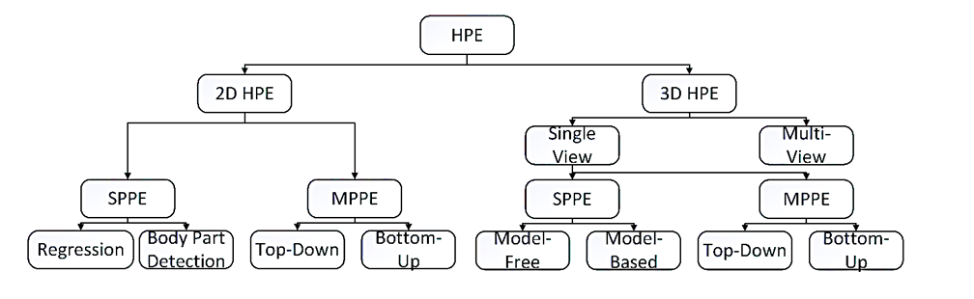

Figure 1: Conventional Classification of 2D and 3D Human Pose Estimations

Fig. 1 shows the Conventional classification of 2D and 3D human pose estimations. Where HPE can be classified into two types which are 2D HPE and 3D HPE. For 2D HPE, for 3D HPE is consisted of two approaches which are single and multi-view. Regarding the 2D HPE and the single view for the 3D HPE, pose estimation is divided into Single-person and multi-person categories based on how many persons are being monitored. The easier approach, single person pose estimation (SPPE), ensures that one person is in the frame. On the other hand, inter-person occlusion is an additional issue that needs to be addressed by Multi-person Pose Estimation (MPPE). The MPPE problem has recently received greater interest due to the availability of large multi-person datasets, whereas early attempts to pose estimation mostly focused on SPPE. As the SPPE for 2D HPE consists of Regression and Body part detection, while for the 3D HPE consists of Model-Free and Model-Based. As MPPE for both 2D and 3D are consisting of Top-Down and Bottom-Up [2]. For the Top-Down approach, we first detect persons in the image and then use these boxes to find keypoints. While the Bottom-Up approach uses heat maps to find keypoints, then uses grouping algorithm to map the keypoints for every person. YOLO is an algorithm that uses neural networks to provide real-time object detection with high speed and accuracy, because it only uses forward propagation. YOLOv7 surpasses many object detector algorithms with an accuracy of 56.8% average precision, as shown in Table 2, As YOLOv7 has 75% fewer parameters than YOLOv4, with 36% less computational time and 1.5x times higher average precision than YOLOv4. In the span of 5–160 frame per second, YOLOv7 exceeds all other known classification techniques in terms of accuracy and speed, and on GPU V100, it has the greatest accuracy of 56.8% average precision between all real-time object detectors with 30 frame per second or more [3].

Table 2: Comparison with other Real-Time Object Detectors [3].

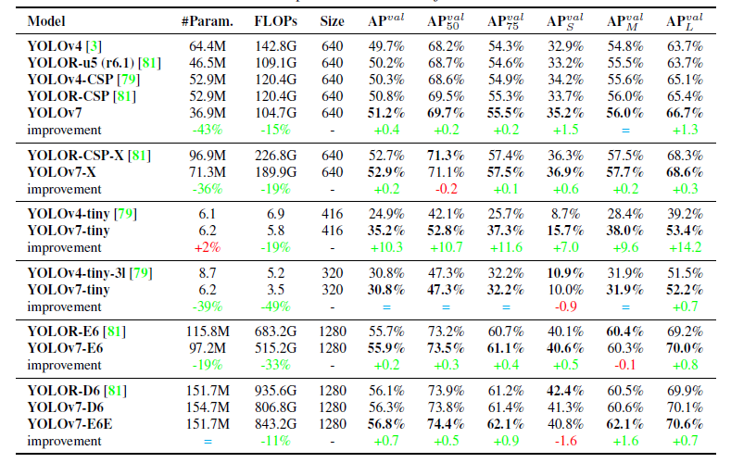

## Literature Survey

### Motion Tracking for Consoles

Pose estimation has also been used in video games, in which human players create and integrate their own poses into the game world to provide engaging and dynamic experiences. For example, Microsoft's Kinect utilizes 3D pose estimation (using IR sensor data) to monitor the movement of human players and to digitally display the activities of players in the game world [4].

### Yoga Poses Trainer and Recognition.

Yoga positions must be executed correctly, as in any workout, because any improper position is ineffective and can even be harmful. This promoted yoga with a teacher nearby. In today's lifestyle, it is not always feasible to have trainers or attend yoga courses. AI-based technology assists in recognizing yoga positions and offers user feedback and recommendations. These guidelines assist users in making their poses more advantageous than harmful. The problems in this project are that models should operate correctly even when body parts overlap and that critical spots should be identified without any missing points. As even minor modifications may have negative effects, precise recommendations should be made. Specialists must perform poses on the datasets used in this study. However, if they are in identical positions with small variations, the models should classify the poses appropriately. Automated self-training techniques for athletes can improve their production and decrease their chance of injury. Several researchers have devised computerized methods to analyse strength training activities, including soccer rankings, handball smashes, sprinting and leaping. Click here to enter text. Figure 2 shows how the yoga pose estimation process can be implemented [5].

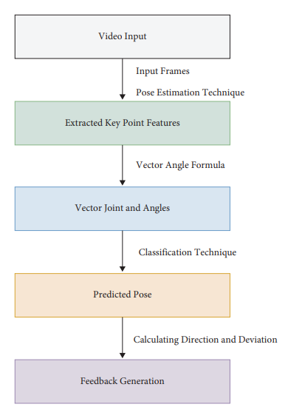

Figure 2: Overview of a Yoga Pose Trainer.

### Human Posture Estimation

Human body modelling is a crucial component of human pose estimation that represents vital information and traits retrieved from the input data. For example, most human pose estimation approaches utilize an N-joint solid kinematic model. The human body is a complex system containing joints, limbs, and information regarding the body's shape and kinematic structure. Model-based approaches are frequently used to deduce and generate 2D/3D human body positions. In general, three distinct types of models are available for human body modelling: kinematic (used for 2D/3D human pose estimation), planar (used for 2D), and volumetric (used for 3D). In the kinematic model, the human body structure is represented by a kinematic model using a collection of joint locations and limb orientations (Fig. 3 (a)). A popular graph model, commonly referred to as the tree-structured model, is the pictorial structure model (PSM). Both 2D and 3D human pose estimations employ this adaptable and simple human body model. The kinematic model is constrained in its ability to express texture and shape data, although it has the benefit of a flexible graph representation. As for the planar model, the planar model is applied to illustrate the formation and look of a body in addition to the kinematic model, which captures the relationships between various body components, as illustrated in Fig.3 (b). Body components are often shown in planar models as boxes that approximate the shape of the human body. which is composed of rectangular body component forms that represent a person's limbs. In a previous study, human pose estimation utilized a cardboard model. Another ex. is the Active Shape Model (ASM), which is frequently used to apply principal component analysis to capture the entire human body graph and silhouette deformations. In addition to previous body modelling, there is a volumetric model. With the growing interest in 3D human rearrangement, several volumetric human body models have been developed for a range of human body types (see Fig. 3(c)). A popular model for 3D human pose estimation is the Skinned Multi-Person Linear (SMPL) model, which may be represented by organic deformations based on pose-dependency displaying dynamics relating to soft-tissue. Available are 1786 high-quality 3D scans of unique humans in postures with template meshes in SMPL to improve blend weights, pose-dependent blend shapes, the average template shape, and the regressor from vertices to joint positions to understand how people change with the pose. Other well-known volumetric models are GHUM & GHUML (ite), DYNA, Stitched Puppet model, Frankenstein & Adam.[6]

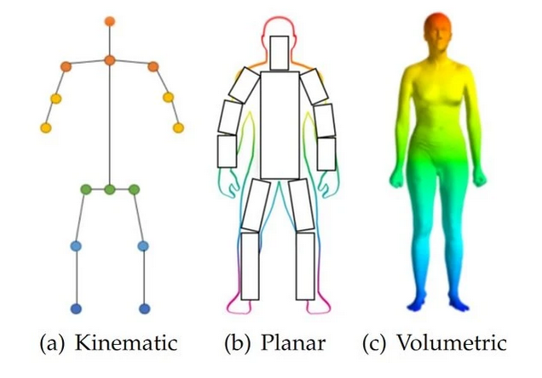

Figure 3: Models for Human Body Modelling

## Analysis of the Related Work

### Motion Tracking for Consoles

There are various evaluation methods for 2D human posture estimation because different datasets have varied properties and variable job requirements (single/multiple person). Table 3 provides a review of the many evaluations that are often applied.

Table 3: Summary of Commonly Used Evaluations Metrics for 2D Human Pose Estimation

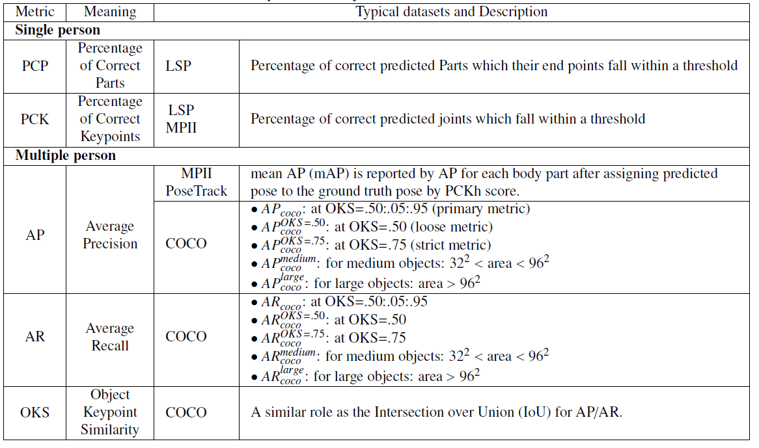

As represented in the previous table, PCP stands for the percentage of correct parts, where if a limb's two ends are within a certain distance of the matching ground-truth endpoints, it has been appropriately localized. The threshold may be set at 50% of the limb length or, as a corresponding threshold, at the median ground-truth segment length over the whole test set. The mean PCP and several limb PCPs are typically recorded in addition to the mean PCP.

PCP equation at a threshold of 0.5 (PCP@0.5) can be calculated as follows:

(1)

PCP@0.5 = (# of correct parts) / (# of total parts)

PCK, which is the percentage of correct keypoints, evaluates the correctness of human joint localization. If an expected body joint is within the threshold pixels of the ground-truth joint, it is accurate. The threshold may be a percentage of the person's bounding box a pixel radius scaled by the test sample's torso height, or 50% of the head segment length (referred to as the "[PCKh@0.5](mailto:PCKh@0.5)").

PCK@0.5 = (# of correct keypoints within 50% of head size) / (sum of keypoints)

(2)

The ground-truth joints are places where each joint is surrounded by a circle with a radius equal to 50% of the ground-truth segment length [7]. b) Three predicted joint pairings, although only the one with the green rectangle is considered accurate. One of the two joints in the other two predictions did not depend on 50% of the length of the ground-truth segment (Fig. 4) [8].

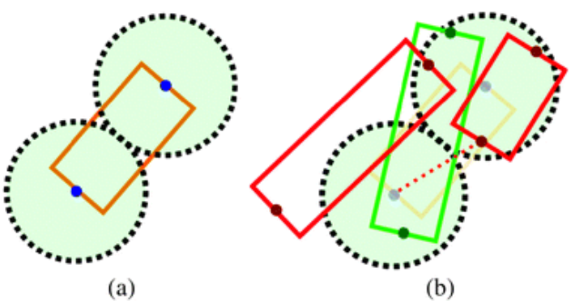

Figure 4: Representation of Ground-Truth Joints [8].

In AP, the detection difficulty must also be handled When human body/head bounding boxes are absent and only joint positions are available used as ground truth during testing. If a point falls within the threshold, it counts as a true positive. Averagerecall (AR) was further developed to evaluate the outcomes of multi-person posture estimation as an object identification challenge. Based on an equivalent similarity metric, the object Keypoint similarity (OKS), which serves the same purpose as the average recall, Intersection over Union, average precision, and their variations, is provided (IoU). Additionally, the COCO dataset reports the average precision/average recall with various human body scales. The assessment measures are listed in Table 2 [3].

As below there is equations to calculate the AP:

(3)

P = TP/ (TP + FP) = TP / Total Predictions

True Positives (TP): The model predicted a class and pair accurately for each ground truth.

False Positives (FP): The model predicted a class, but it is not a part of the ground truth.

As below there is equations to calculate the AR:

(4)

R = TP / (TP + FN) = TP / Total Ground Truths

True Positives (TP): The model predicted a class and pair accurately for each ground truth.

False Negatives (FN): The model does not predict a class, but it is part of the ground truth.

As below there is equations to calculate the OKS:

(5)

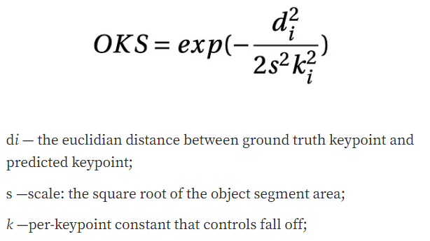

di is the Euclidean distance in the middle of predicted key-point and ground truth key-point.

s is the square root of the object segment region.

k is per-key-point constant that operates fall off.

### Analysis Yoga Poses a Trainer and Recognition.

The methods described in this study apply deep learning to identify improper yoga poses and provide user advice on how to straighten. The computation of vectors for each joint, identification of key-points using a pose estimation technique, and angle between the vectors for neighbouring joints are all characterized as features in this study, which is divided into three sections: extraction of key-points for every frame, classification, and generating feedback for the current yoga pose. Table 4 and figure 5 show the accuracy of the models used in this study [5].

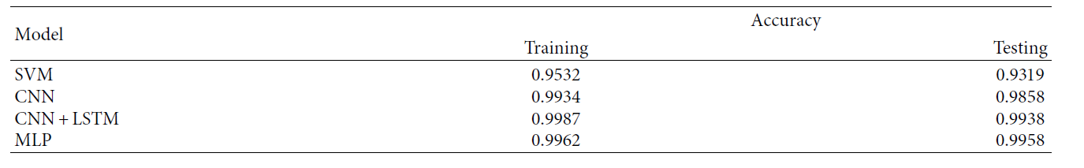

Table 4: Represtation for Model Accuracy

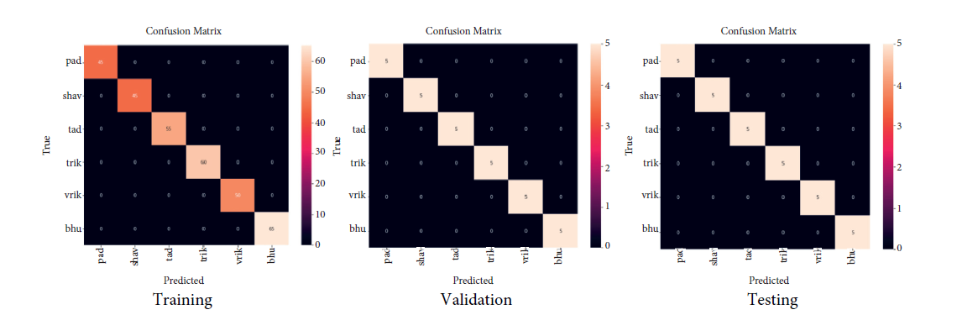

Figure 5: Confusion Matrices for Training, Validation, and Testing of the Dataset.

# Proposed solution

## What is YOLOv7?

The YOLOv7 is a single-stage model object detector that functions in real-time. In July 2022, it was included to the YOLO series. It is now the most efficient and most accurate real-time object detector accessible, according to the YOLOv7 report. The performance of YOLOv7 has improved, marking an important achievement. The precision and quickness of YOLOv7 have been effectively increased by the implementation of several structural upgrades. Like Scaled YOLOv4, YOLOv7 uses backbones that are fully learned on the COCO dataset rather than being pre-trained on ImageNet [3]. It is expected that YOLOv7 and Scaled YOLOv4 have some similarities given that the same authors that created Scaled YOLOv4 and YOLOv4 were also involved in creating YOLOv7.

### YOLOv7 Used Approach

In pose estimation there is two general approaches which are Top-Down approach and Down-Top approach. For the Top-Down approach, we first detect persons in the image and then use these boxes to find key-points, Fig. (6). As you can assume that this would give a good result but, it would be too slow, if there are many people in the frame.

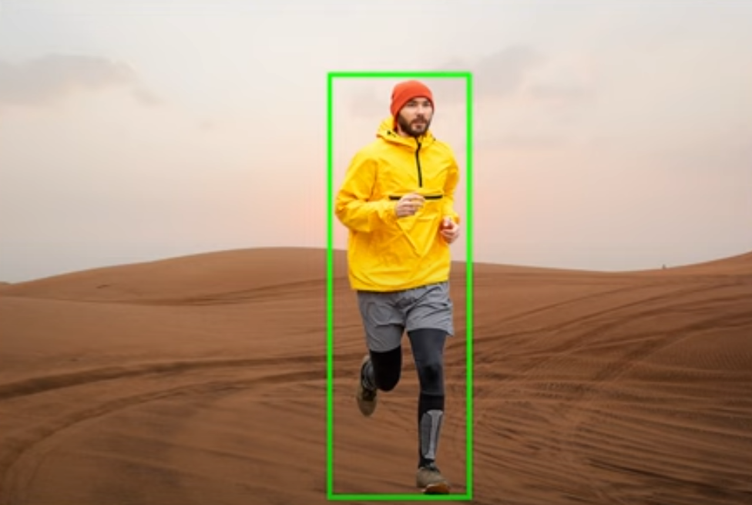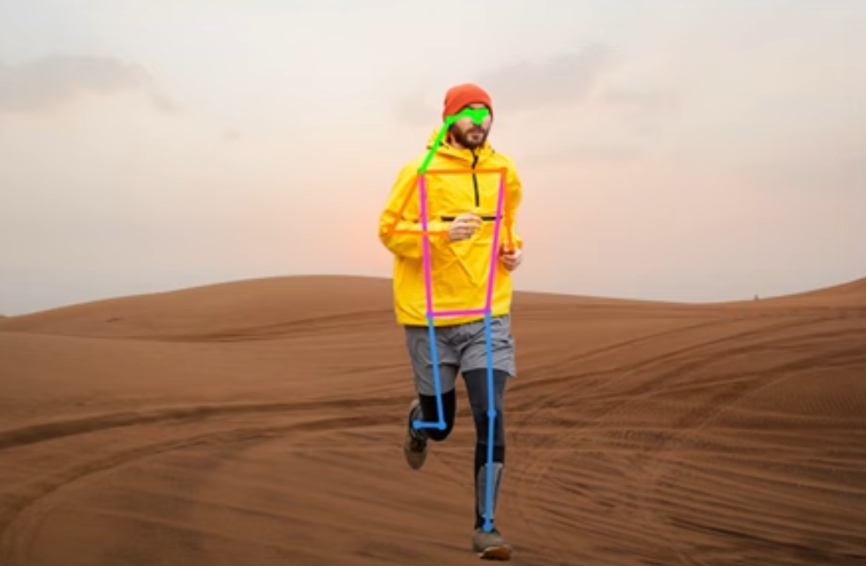

Figure 6: Top-Down Approach

While the Bottom-Up approach uses heat maps to find key-points, then uses grouping algorithm to map the key-points for every person, Fig. (7). As it is a single stage so it is fast it will be very accurate in case of crowded scenes.

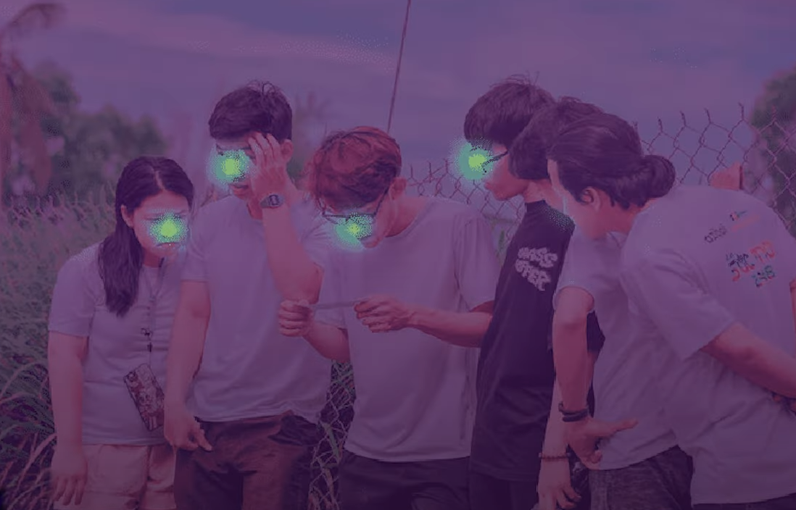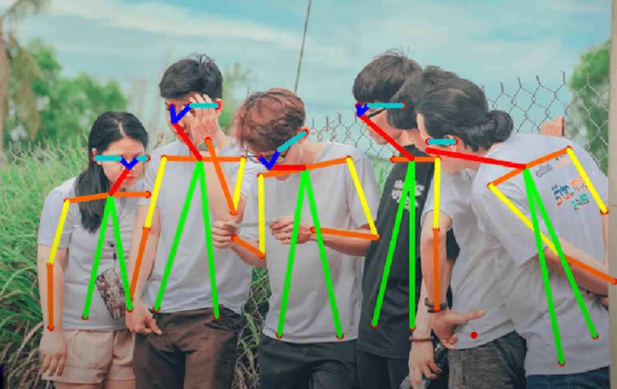

Figure 7: Bottom-Up Approach

So, YOLO optimizes the OKS metrics where it detects the key-points as well as the bounding boxes, so there is no need to apply the grouping algorithm done in the Down-Top approach. As the key-points and the bounding boxes are predicted in a single stage it does not affect the speed. What YOLO has done is to gather what is best in both approaches and present it [8].

## Architecture

### Extended Efficient Layer Aggregation Network

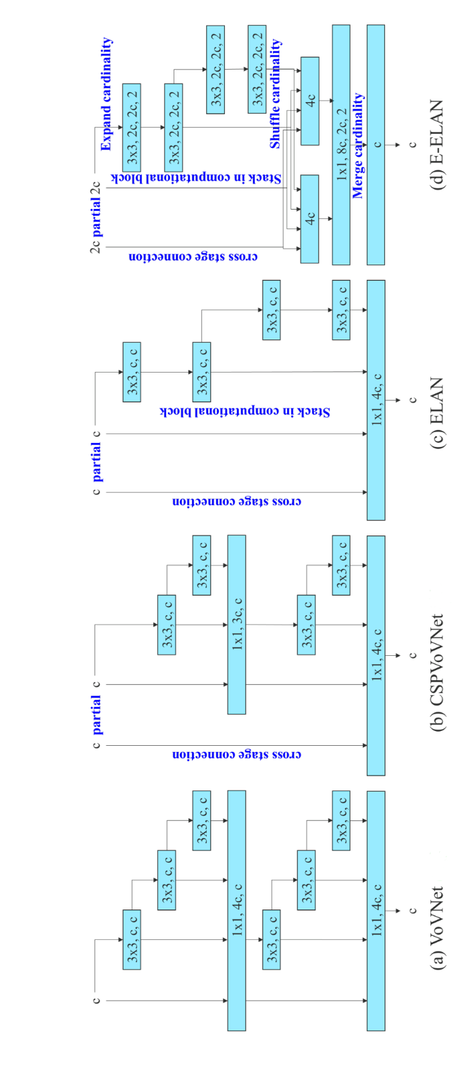

Figure 8: Extended Efficient Layer Aggregation Networks.

The creation of effective neural network topologies involves several factors and techniques. The most important elements that are normally considered are the number of parameters, computing power, and computational density. On network inference speed, the effects of memory access cost, input/output channel ratio, the number of branches, and element-wise procedures are also examined. The idea of model scaling was first put forth by Dollar et al., who focused on the quantity of elements in the output tensors of convolutional layers. According to figure 8, By taking gradient routes into account to enable diversified feature learning in various levels, the CSPVoVNet architecture expands the VoVNet design. To enhance deep network learning and convergence, ELAN suggests controlling the shortest and longest gradient routes. By adding expand, shuffle, and merge cardinality strategies that improve network learning capacity without obstructing the original gradient paths, Extended-ELAN (E-ELAN) expands on ELAN. Only the computational block design is altered by E-ELAN; the transition layer architecture is left untouched. With each computational block yielding feature maps that are shuffled and concatenated, group convolution is employed to increase channel and cardinality [3]. Lastly, by including numerous groups of feature maps, merge cardinality is applied. The original ELAN design architecture is preserved by E-ELAN, which also directs various computational block groups to learn various properties. Group convolution and shuffle-fling merged cardinality are two techniques used by E-ELAN to boost the cardinality of additional features. The gradient of the original architecture is not changed by this.

### Model Scaling for Concatenation-Based Models.

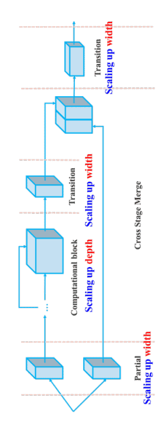

Figure 9: Model Scaling for Concatenation-Based Model

model scaling for concatenation-based models, which involves adjusting various attributes of a model to generate models of different scales to meet specific inference speed requirements. For instance, EfficientNet and scaled-YOLOv4 consider attributes such as width, depth, resolution, and the number of stages for scaling. The influence of vanilla convolution and group convolution on parameters and computations during width and depth scaling is analyzed, leading to the development of corresponding model scaling methods. These methods are primarily used in architectures like PlainNet or ResNet, where the in-degree and out-degree of each layer remain constant during scaling, allowing independent analysis of each scaling factor's impact. However, in concatenation-based architectures, scaling the depth factor affects the in-degree of a translation layer following a concatenation-based computational block, leading to a need for simultaneous consideration of different scaling factors as shown in Fig (9). For example, scaling up depth alters the ratio between input and output channels in a transition layer, potentially reducing hardware usage. To address this, a compound model scaling method is proposed for concatenation-based models. When scaling the depth factor of a computational block, the change in the output channel of that block is calculated. Subsequently, width factor scaling is applied to the transition layers with an equivalent amount of change as shown in Fig (9), preserving the model's initial design properties, and maintaining optimal structure [3].

### Planned Re-Parameterized Convolution.

RepConv has displayed impressive results on VGG, but its accuracy is significantly lowered when applied directly to other architectures such as ResNet and DenseNet. For this problem, they have employed gradient flow propagation routes to investigate how re-parameterized convolution can be integrated with various networks, resulting in the development of intentional re-parameterized convolution. Through the analysis, they have found that the identity connection in RepConv destroys the residual in ResNet and the concatenation in DenseNet, thus reducing the diversity of gradients for different feature maps. As a solution, they have proposed using RepConvN that does not contain identity connections when replacing a convolutional layer with residual or concatenation. This planned re-parameterized model was applied to PlainNet and ResNet, Fig (10) [3].

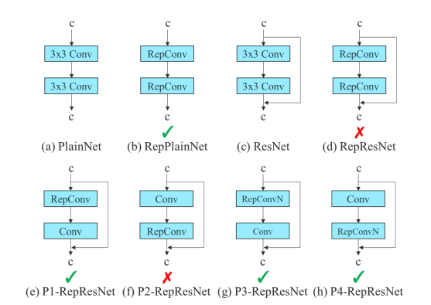

Figure 10: Planned Re-Parameterized Model.

### Coarse for Auxiliary and Fine for Lead Loss

Deep supervision is a popular technique for training deep networks. It involves adding auxiliary heads in the middle layers of the network and using shallow network weights with an assistant loss to guide the training process. Even highly successful architectures, like Res-Net and DenseNet, can benefit significantly from deep supervision in many tasks. Fig 12 (a) and (b) illustrate an object detector architecture "without" and "with" deep supervision, respectively. The so-called lead head produces the final output, while the auxiliary head has the primary task of facilitating training. Label assignment in the past used to directly refer to the ground truth and create hard labels using predefined rules. However, more recent researchers have utilized the quality and distribution of the network's prediction output along with ground truth to generate more reliable soft labels using various calculation and optimization techniques. This more advanced methodology is referred to as "label assigner" in this paper. Regardless of the lead head or auxiliary head, deep supervision must be trained on target objectives. During the development of label assigner techniques, the authors of this paper unexpectedly stumbled upon a new derivative issue: "How to assign soft label to auxiliary head and lead head?" The proposed label assignment method guides both the auxiliary head and lead head using the lead head's prediction output to generate coarse-to-fine hierarchical labels for the two heads' respective learning processes. The novel label assignment approach is shown in Fig 12 (d) and (e), respectively.

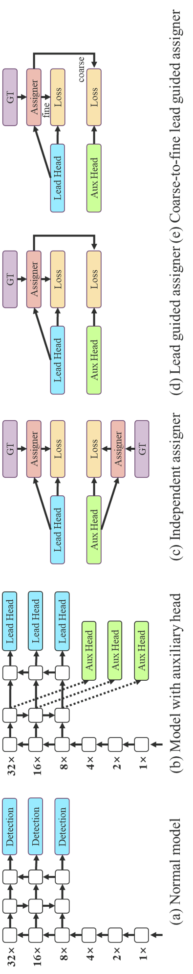

Figure 11: Coarse for Auxiliary and Fine for Lead Head Label Assigner.

The lead head guided label assigner generates a set of soft labels by using the prediction result of the lead head and the ground truth, which are obtained through an optimization process. These soft labels are then used as target training data for both the auxiliary head and the lead head. The soft label generated from the lead head is considered more representative of the distribution and correlation between the source and target data due to its strong learning capability. The auxiliary head, on the other hand, focuses on learning the residual information that has not yet been learned, by directly learning the information that the lead head has learned. The lead head guided label assigner generates soft labels using the predicted result of the lead head and ground truth, producing both coarse and fine labels. Coarse labels are produced by considering more positive targets, relaxing constraints of sample assignment, while fine labels are the same as those generated by the lead head guided label assigner. This approach improves the recall of the auxiliary head in object detection, as its learning ability is weaker than that of the lead head. To obtain the final output, the lead head's result is filtered to select high precision from high recall results. However, restricting the weight of coarse labels is necessary to prevent bad predictions. This mechanism adjusts the importance of both fine and coarse labels dynamically during learning, ensuring the upper bound of optimizable fine label is always higher than coarse label [8].

## Solution

Professional trainers have said that there is nothing called doing the exercise perfectly, but there is something called an acceptable form that this project is trying to do. The proposed solution was constructed in three main steps.

* **Feature extraction:** A video was captured in real time as an input, frames were captured at regular intervals, and critical spots were retrieved using YOLOv7 pose estimation, as shown in Fig 13. These focal points were used to construct the 12 joint vectors. The angles between the x-axis and 12 joints were calculated for each joint.

|  |  |
| --- | --- |
| (a) (b) |  |
| Figure 12 : Arctan2 Funtion Between Vectors [10]. | Figure 13 : A Pre Trained Keypoints Detection with yolov7-w6-pose.pt. |

* **Calculation of angle:** Using the arctan2 method, the radians of the line created by the first and middle landmarks, line of origin, and point (1,0), as well as the radians of the line created by the middle and end landmarks, line of origin, and point (1,0). The angle formed by the three landmarks then takes the place of the two radians. We transformed the radians into degrees to better comprehend the angles Fig 12 (a). For example, if we have two vectors as shown in Fig 12 (a) and we want to get the angle between them. We perform the equation on each vector as shown in Fig 12 (b), as the value of V2 is the θ1 from x-axis, and V1 is θ1+ θ2, where θ2 is the angle between V1 and V2. After we have each vector value which have been calculated in radian, we must subtract one vector from the another to get the value between both vectors. As this Is the used formula:

(6)

V2 = Atan2(y3-y2, x3-x2)

(7)

V1 = Atan2(y3-y2, x3-x2)

(8)

∴ new θ = V2 -V1

(x1, y1) à coordinates of a point on a graph

(x2, y2) à coordinates of a point on a graph that is usually act as the origin.

(x3, y3) à coordinates of a point on a graph

V1 à object that represent magnitude and direction. for example, from 6 to 5 from Fig (13)

V2 à object that represent magnitude and direction. for example, from 6 to 7 from Fig (13)

new θ à the angle between to vectors. For example, angle at 6 from, Fig (13)

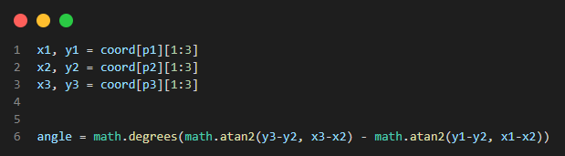

Figure 14: Code Snippets for Calculating Angles Between Two Vectors

* **Calculation of distance:** I have used Euclidean theorem to find the distance between two points. Where (p1, q1) is coordinates of the first point, (p2, q2) is coordinates for the second point. As we square root the difference between p2 and p1 all squared, then add to them the difference between q2 and q1 all squared.

(9)

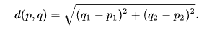

(p1, q1) à coordinates of a point on a graph

(p2, q2) à coordinates of a point on a graph

d (p, q) à distance between (p1, q1) and (p2, q2)

The result will be in number of pixels, so I have assumed that 1 pixel = 0.1 cm. To convert pixels to cm, we multiply distance in pixels to 0.1. as below is a code snippet of how it has done.

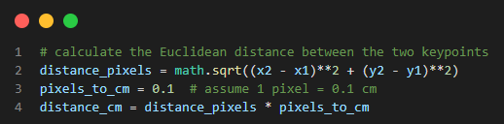

Figure 15: Code Snippets for Calculating Distance Between Two Keypoints.

* **Generating feedback:** As a part for motivating the trainee to reach his goal, I have generated a voice over texts using gtts, as that could help the trainee to reach his goal without giving him the feeling of being tired or exhausted. When an incorrect form is detected, the program alerts the user in the wrong form have been done.

## Biceps Curl Exercise

### What is Biceps Curl Exercise?

Biceps curl is a well-known weight-training exercise that targets the upper arm muscles and, to a minor extent, the lower arm muscles. This exercise is important for improving the building strength. This exercise can be performed using a variety of tools and grips such as dumbbells, kettlebells, barbells, resistance bands, and cable machines. The curl is a common exercise for upper-body strength training. You can develop upper arm strength and learn how to use your arm muscles correctly by performing biceps curls regularly. This will teach you to brace your core muscles. Curls work on the bicep's muscles at the front of the upper arm and the muscles of the lower arm, brachialis, and. These muscles were used whenever they were selected. something up, which is common in daily life [11].

Elbow

Wrist

Shoulder

ROM

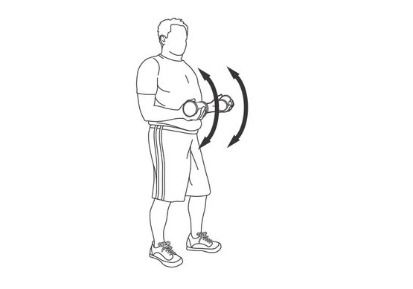

Figure 16: Biceps Curl Exercise

### Common Biceps Curl Exercise Mistakes

#### Cutting Your Range of Motion of Biceps Curl Exercise

Cutting your ROM is not a reason for getting an injury; it only decreases the result you will have. Therefore, for example, the trainee strictly follows the listed instructions, as the status of how the elbow angle is, where it is in the down state as the trainee’s arm is at a straight line. Then, after the user inclines his arm with the specified threshold, then straightens his arm to repeat the process, as if the trainee followed up the instructions. In a recent study, participants were instructed to perform biceps curls under two separate conditions. One group performed only the top half of the curl, whereas the other group performed only the bottom half using a weight that corresponded with their strength in each position. The experimenters measured three points on the biceps of each participant. After 5 weeks, the group that performed only the bottom half had nearly 2.6 times more biceps growth on average when compared to the other groups. Notably, most of the growth occurred at the third measurement site, situated towards the bottom area of the bicep [12]. A conclusion from what has been said is that the trainee must take into consideration the contraction and relaxation of a muscle, as it should follow specific conditions to obtain the best result in a brief time.

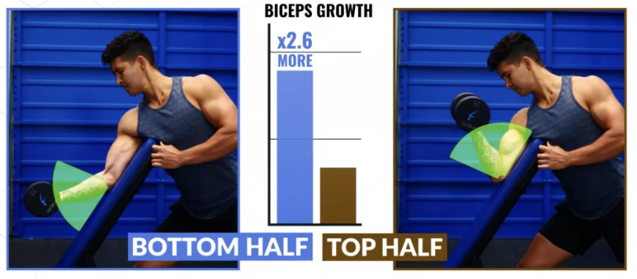

Figure 17: Importance of Contraction and Relaxation

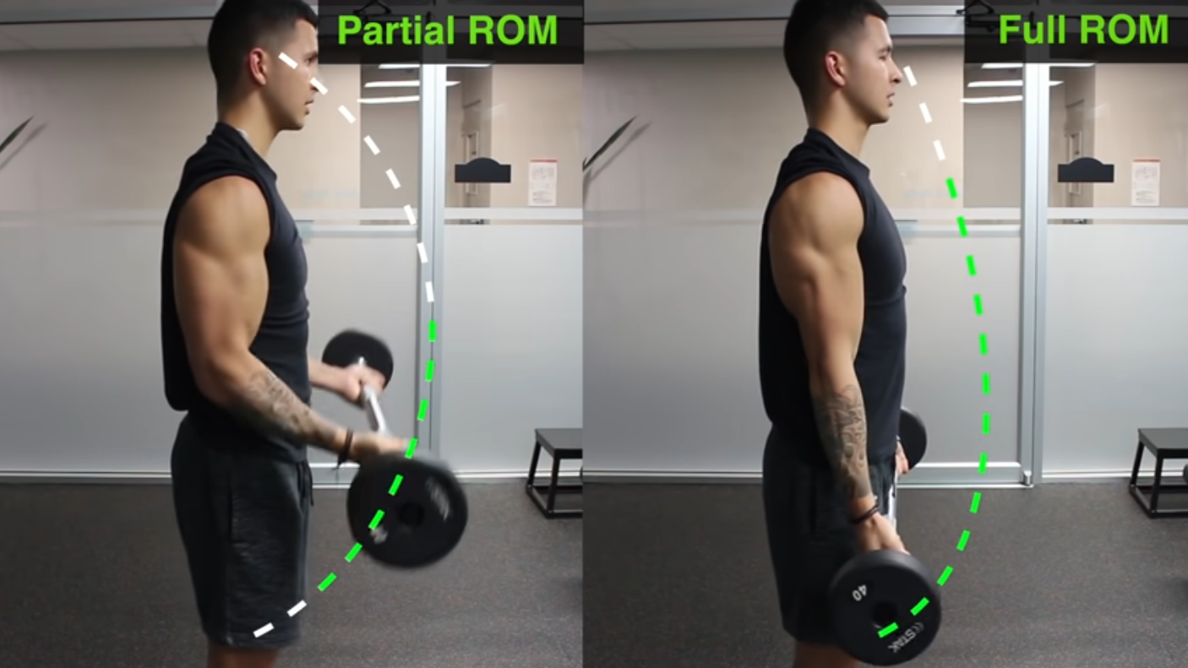

Figure 18: Comparison Between Partial ROM and Full ROM

#### Swaying Elbows to the Sides

Swaying the elbows to the sides while performing the exercise could result in injury to the trainee, which is what we are trying to avoid; therefore, the trainee should keep his elbows beside his body with a maximum shoulder angle of 35 °. If the trainee has opened his shoulder angle more than it should be, which puts a heavy load on the trainee’s wrist bones that could result in wrist pain [13], it could also result in pain as the elbow moves in a way that should not move in.

#### Wide Wrist Distance

While performing the exercise, many trainees do not keep the distance between the right and left wrist the same as the distance between the right and left shoulders; therefore, the trainee could get injured in his elbow, as it puts a load on the elbow bones and will not affect muscle growth and will also not build the muscle in the proper shape [12].

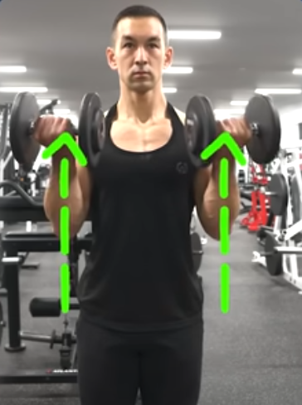

Figure 19: Avoid the Shoulder from Exceeding the Threshold and Prevent the Distance Between the Two Wrists from Exceeding the Shoulder Distance.

### Avoiding Biceps Curl Mistakes

A popular weight-training exercise known as the biceps curl targets the upper arm muscles and, to a smaller extent, the lower arm muscles. This workout is crucial for enhancing strength development. The trainee should avoid making the listed mistakes to avoid injuries and gain the maximum muscle mass and strength he or she needs. For cutting ROM, trainee needs to do the contraction tell it elbow angle reach 30 degrees, and the relaxation tell the angle tell the angle tell the angle tell the angle tell the angle reach 150 degrees. To avoid swaying elbows to the sides, the trainee’s shoulder angle should not exceed a threshold of 35 degrees as more than this could result in an injury in his shoulder. In addition to what has said, the trainee should keep the distance between both wrists the same as the distance between the shoulders, as he can wide wrist distance with a small margin.by these trainees avoid injuries they could have in their elbow.

## Squats Exercise

### What is the Squat Exercise?

A body resistance exercises that targets leg strength is a squat. The quadriceps and hamstrings are the muscles specifically targeted by the squat. Your performance in several sports will improve, and your knees will be better off if these muscles are strengthened [14]. Stand with feet slightly wider than shoulder width apart, and toes facing forward to perform the exercise. Slowly descend while bending the knees, ankles, and hips. When the knees were 90 °from the floor, stop. Then, go back to where you are. You will feel tension in your buttocks and legs. Keep your back in a neutral position as you perform the squats. Avoiding flattening the curve of the lower back and avoiding the opposite. On the way down, make sure your knees stay directly above your feet. Make sure your knees are not rolling in or out. Simply lower yourself as low as you can if you are unable to bend your knees to a 90-degree angle. For support and balance, use your arms. When you start to feel tired or your form starts to degrade, stop.

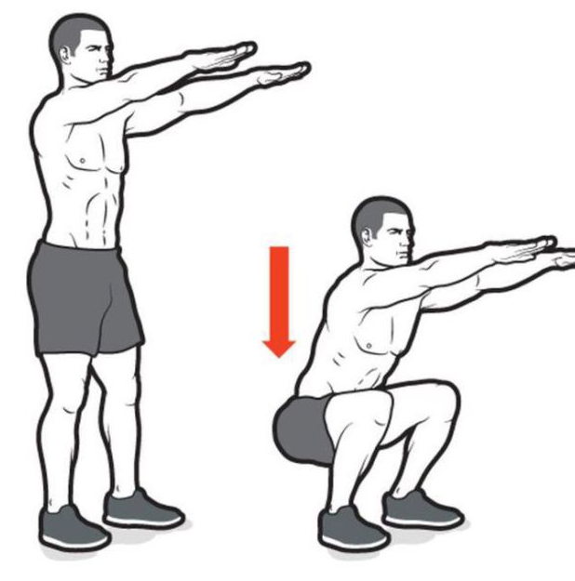

Figure 20: Squats Exercise Forms

### Common Squats Exercise Mistakes

#### Cutting Your Range of Motion of Squats Exercise

To get the best performance out of doing the exercise, the trainee should Slowly descend while bending the knees, ankles, and hips. When his knees are 90 degrees from the floor, hip angle should be at 60 degrees, stop. then go back to where you were. The trainee will feel the tension at your buttocks and legs. Keep your back in a neutral position as you perform the squats. Mistake done by the trainee is that they do not bend either their knees or hip angle as they should. After doing this for many times, the trainee will not see a progress on their muscles as he or she do not feel the tension at their buttocks as it is a flag that the trainee is doing the exercise in the proper way. As shown in figure (17), it is the four stages of doing the exercise, where cutting the ROM happens when he goes from the first stage to the third stage and neglect reaching the fourth stage.

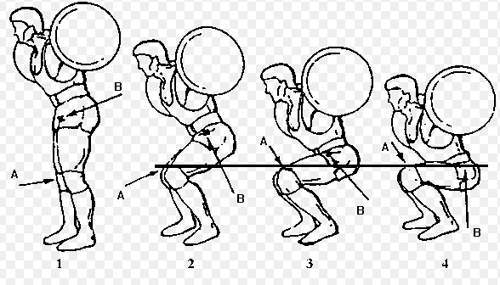

Figure 21: Four Stages of doing the Squats Exercise.

#### Rising Hips Faster Than Chest

It’s a bad habit being done by beginner trainees, for example, while there are standing and start to do the exercise, they bend their hips before their bending their knees angle, as by doing that you are putting a huge amount of load on their knees, because they must hold all your upper body weight tell you reach the proper position. As this also could be done while standing up from the fourth stage.

#### Ankle Distance is longer or shorter than threshold

Squats exercise is built for legs, especially the buttock. Many people fail for doing the exercise while their ankle distance does not fall in the threshold [15]. As by not following the instructions may cause an injury for the knees, whereas if ankle distance does not fall in the threshold, knees move in a direction where it is not supposed to reach.

### Avoiding Squats Mistakes

A body resistance exercises that targets leg strength is a squat. The quadriceps and hamstrings are the muscles specifically targeted by the squat. As the trainee has two common mistakes, which are cutting ROM and raising hips faster than the chest. The trainee must bend his knees at 90 degrees and hip angle should be at 60 degrees to avoid falling in the mistake of cutting ROM. To avoid rising hips faster than chest, the trainee must open his knee and hip angle in the same speed, having the same rate of change every second compared to each other’s.

## Push Ups Exercise

### What is Push Ups Exercise?

Push ups exercise are one of the most fundamental body weight exercises, as it is highly effective because you are using a lot of muscles at the same time. Push-ups involve pushing the body up and letting it fall by alternately straightening and bending the arms while remaining in a prone posture with the palms of the hands under the shoulders, the balls of the feet on the ground and the back straight. Strengthening the upper body can benefit from performing regular push-ups. They exercise the shoulders, pectorals, and triceps. By contracting the abdominal muscles, they can also strengthen the lower back and core when done with perfect technique. A quick and efficient workout for increasing strength is the push-up. They do not need any special equipment and may be performed from anyplace.

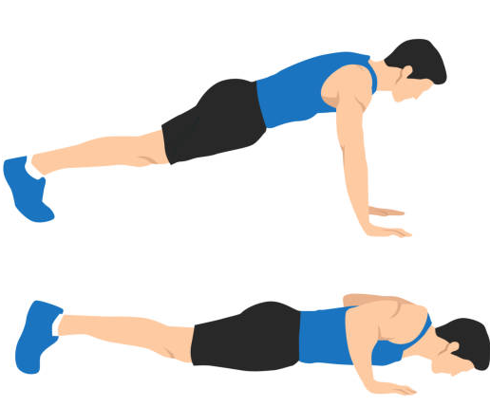

Figure 22: Two Forms of Push Up Exercise.

### Common Push Up Exercise Mistakes

#### Limited ROM

This is done when the trainee does not straighten his arm nor bending it as shown in figure 18. As if he did that this counted as cutting the ROM and cheating, as by cutting ROM trainee will not see a difference and will not gain the muscle mass.

#### Long Distance Between Elbow and the Waist.

A mistake can also be made which is extending the distance between the right and left elbow to be more than the distance between the shoulders. The shoulder angle should not exceed 45 degrees, as if it exceeds this threshold, it will cause an injury in trainees’ shoulder, and will make the exercise more difficult to do.

#### Wrist Distance More Than Shoulder Distance

Many trainees do the exercise while wrist distance is too wide, for a beginner it is too hard to do it, so some trainees widen their wrist to bypass their shoulder distance by a huge margin. By doing this you put your shoulders as if you are not familiar with the exercise in a risk of getting an injury, because you put a lot of loads on your shoulder.

### Avoiding Push Up Mistakes

A trainee must follow some rules to avoid the listed mistakes which are limiting ROM, Long distance between elbow and waist, and wrist distance is more than shoulders distance. To avoid limiting ROM in the exercise trainee must bend his elbow angle till his face reaches the ground, and keep his shoulder angle nearly at 45 degrees, also the trainee must keep the distance between both wrists longer than the distance between the shoulders but with not a big margin. By following the previous steps, the user will be able to avoid injuries and gain his expected results.

# Results and Discussions

## Biceps Curl Exercise

### Doing the Exercise in a Proper Way

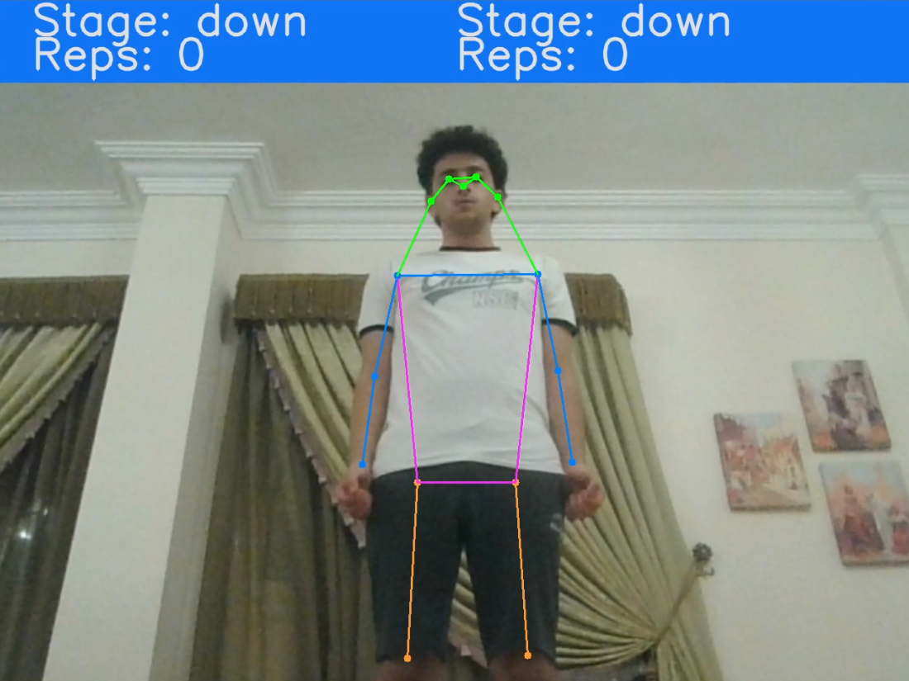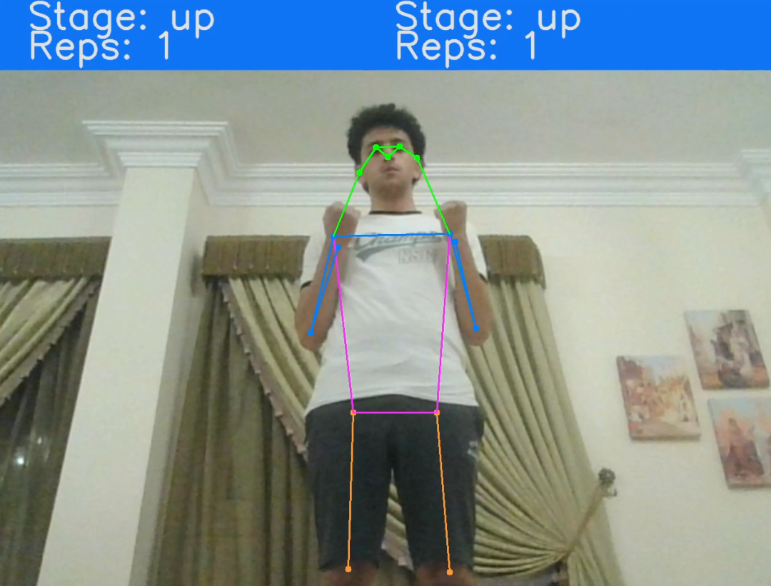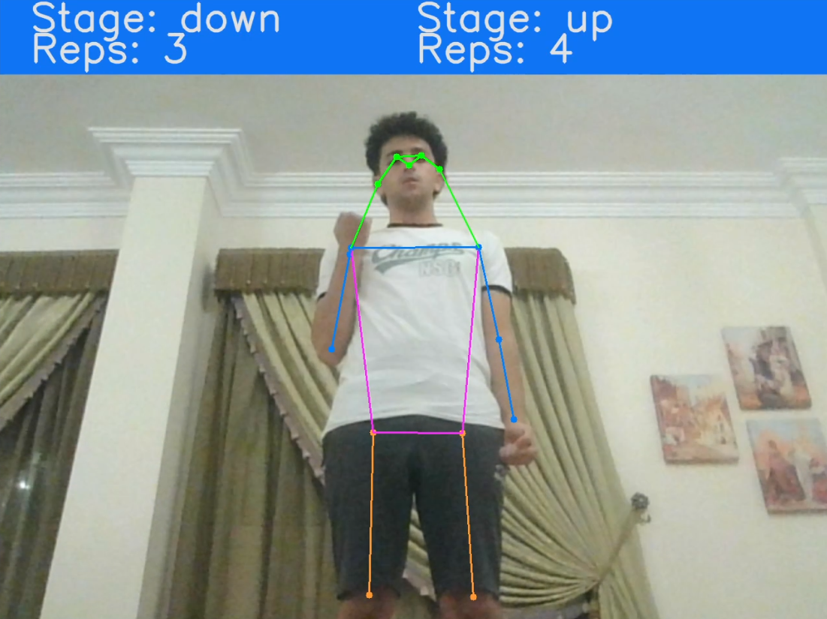

1. (b)  (c)

Figure 23: Biceps Curl Exercise

This section illustrates how the trainee perform the exercise in a proper way. To start, your arm should be at position of 180 degrees that results in changing the stage to be down, as it is the trainee’s current state as shown in figure (a), so he starts to bend his arm to complete the required ROM. It required from him that the contraction phase reach to angle 30 degrees Fig. 23 (b) and (c). As all these steps are required to be done while considering wrists distance, that the distance between left and right wrists should be the same or wider than the distance between left and right shoulder. Once the trainee completes 10 counts on both hands it shows him a message that says “congrates you have done the exercise” Fig. 24.

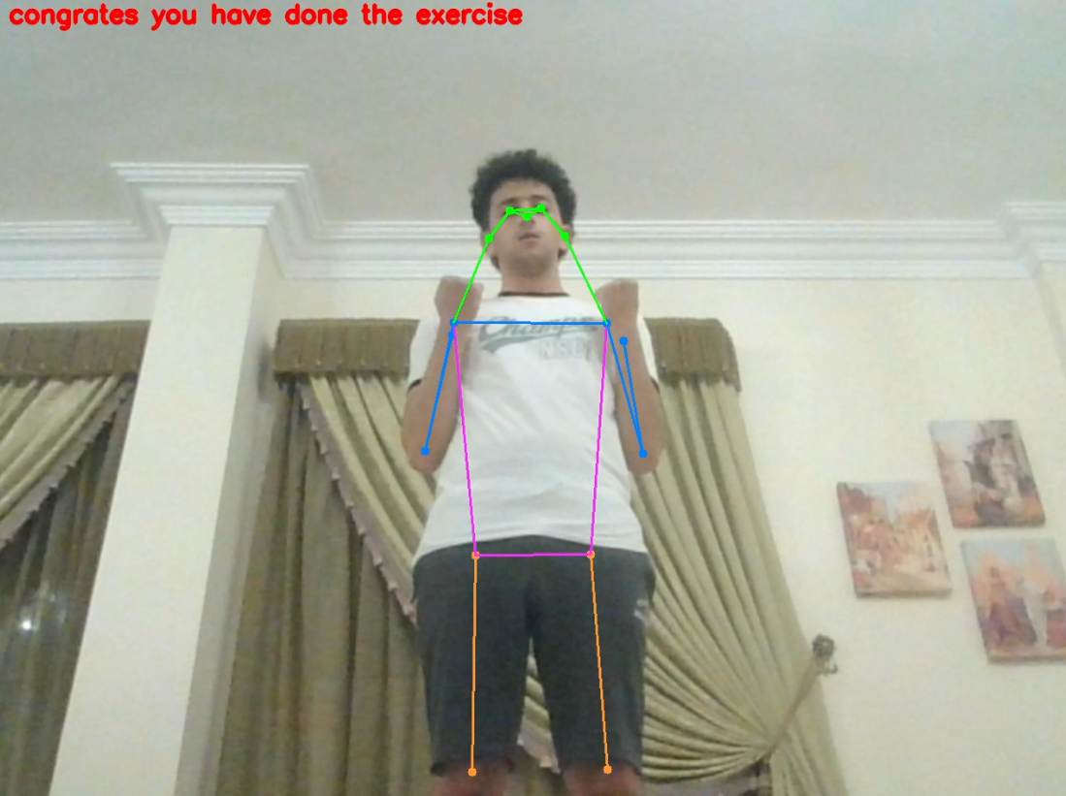

Figure 24: Shown Message When the Trainee Completes the Set

### Doing the Exercise in an Improper Way

#### Exceeding Shoulder Angle Threshold

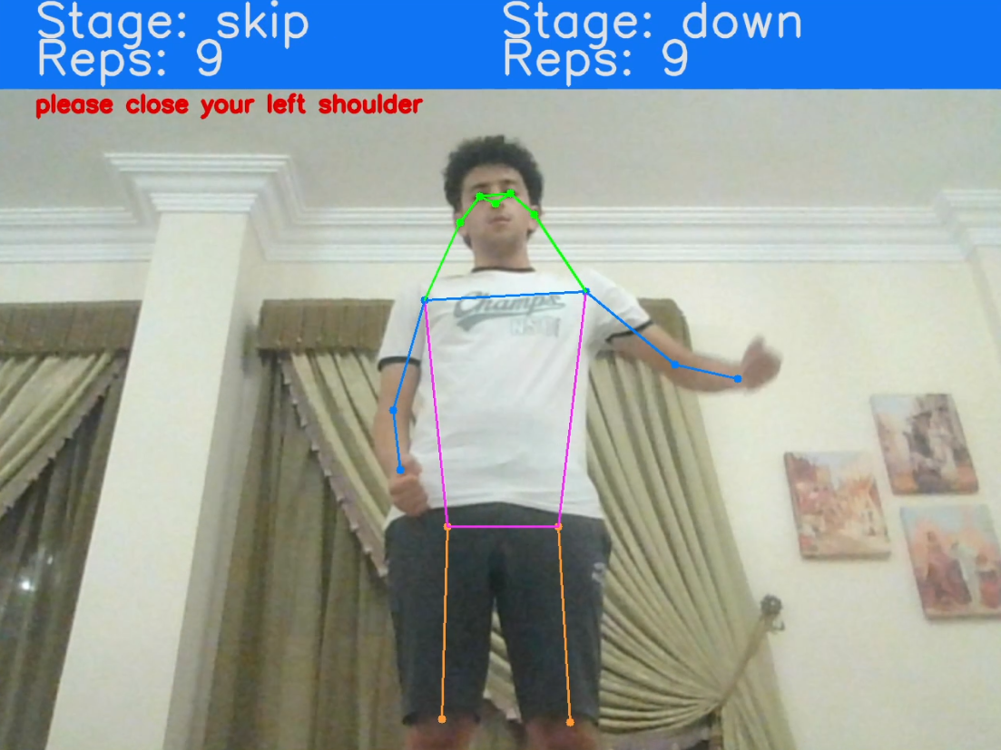

(a)

Figure 25: Trainee Exceed Shoulder Threshold

Here at Fig. 25, the trainee exceeds the set threshold of his left shoulder angle, which is set to be 35 degrees. The program should show the user a warning message in red colour, showing the trainee that he must close his shoulder to meet the required angle.

#### Cutting ROM of the Count

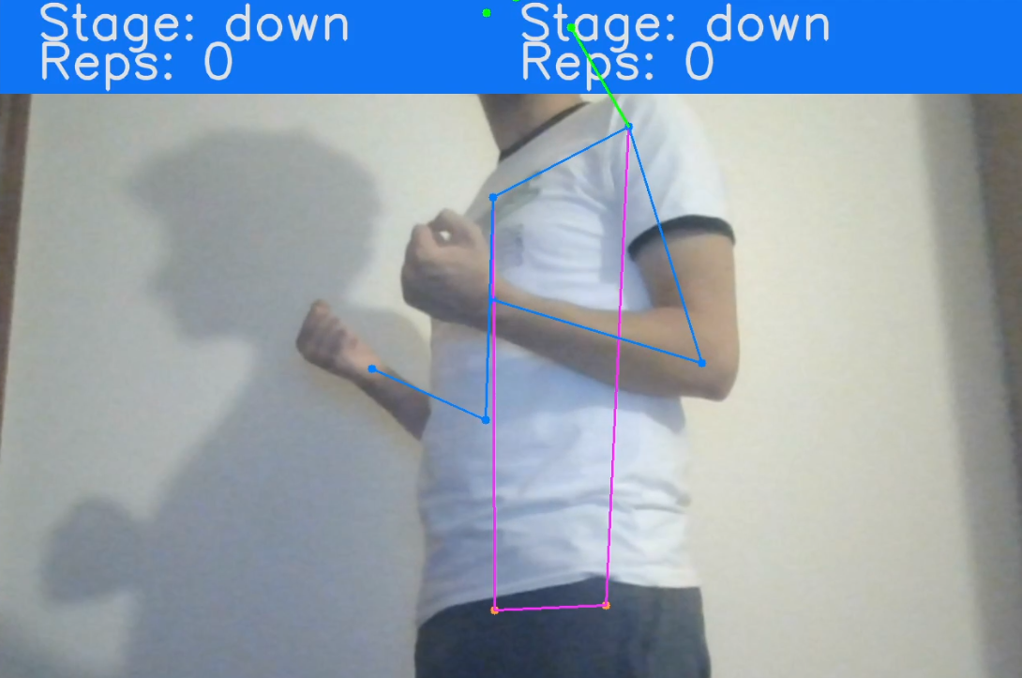

(a)

Figure 26: Cutting Biceps ROM

For Fig. 26, it shows how the program can accurately detect the angle of the elbow, where he should raise his hand more than shown to count, as if he does not bend his elbow enough it will not count.

#### Ensure Distance Between Wrists

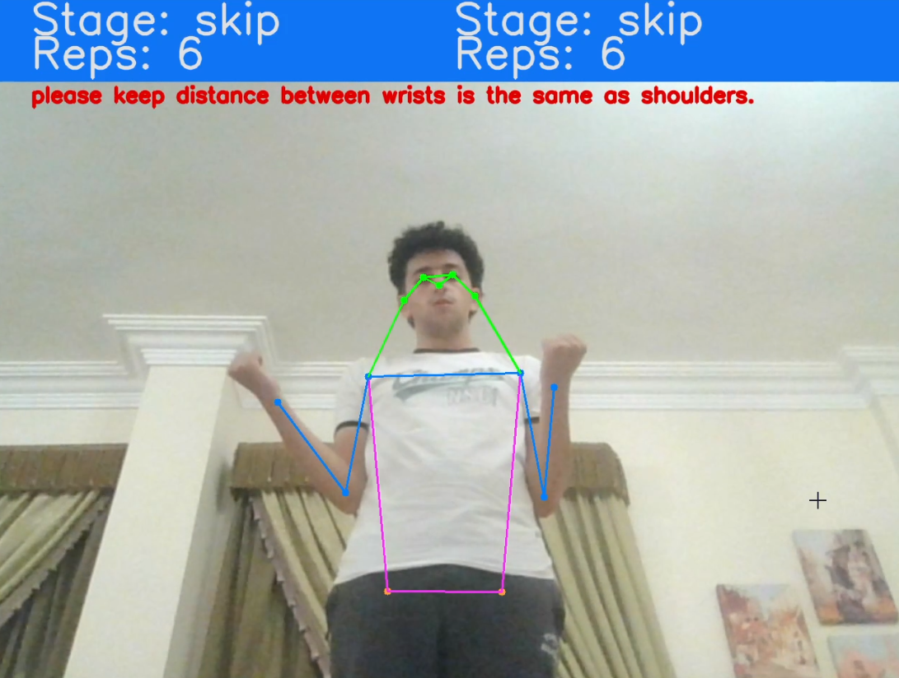

Figure 27: Distance Validation

Using Euclidean theorem, I extract the distance between both wrists. as the above Fig. 27, the trainee has a huge distance difference where it does not should be at this position, as he should move his right arm a little bit to be in his body frame and the distance between both wrists is the same as the distance between both shoulders.

## Squats Exercise

### Doing the Exercise in a Proper Way

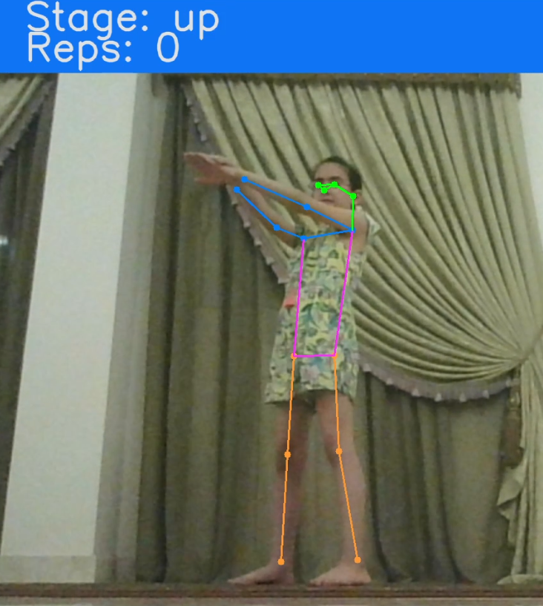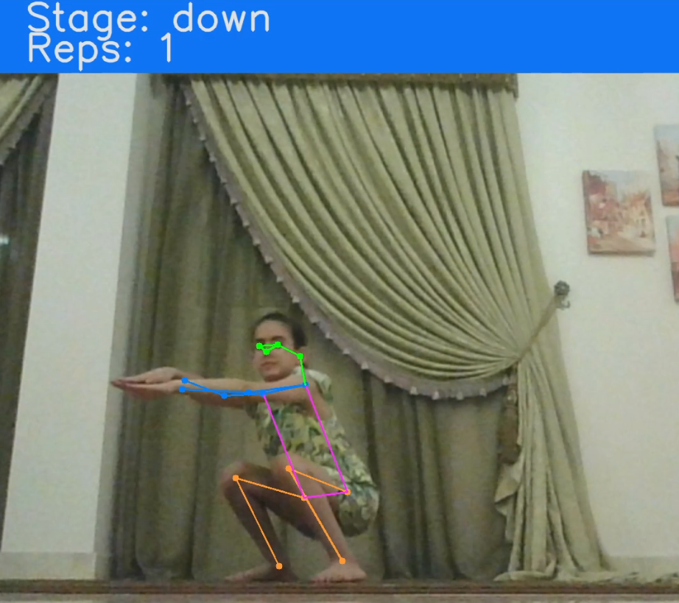

(a) (b)

Figure 28: Squats Exercise Form

Squats exercise is a body resistance exercises that targets leg strength. The first Fig. 28 (a) she starts from the initial state where she is standing up as her knee and hip angle is at 180 degrees. The program starts to count when she starts bending her knees and hip till her buttocks surpasses being parallel to the ground, Fig. (b).

### Doing the Exercise in an Improper Way

#### Ensure Distance Between Ankles

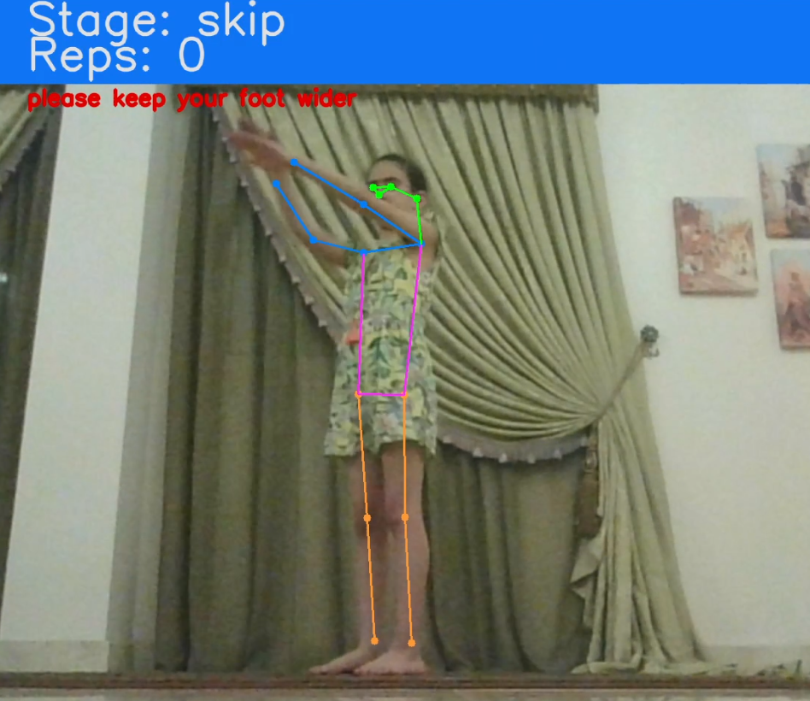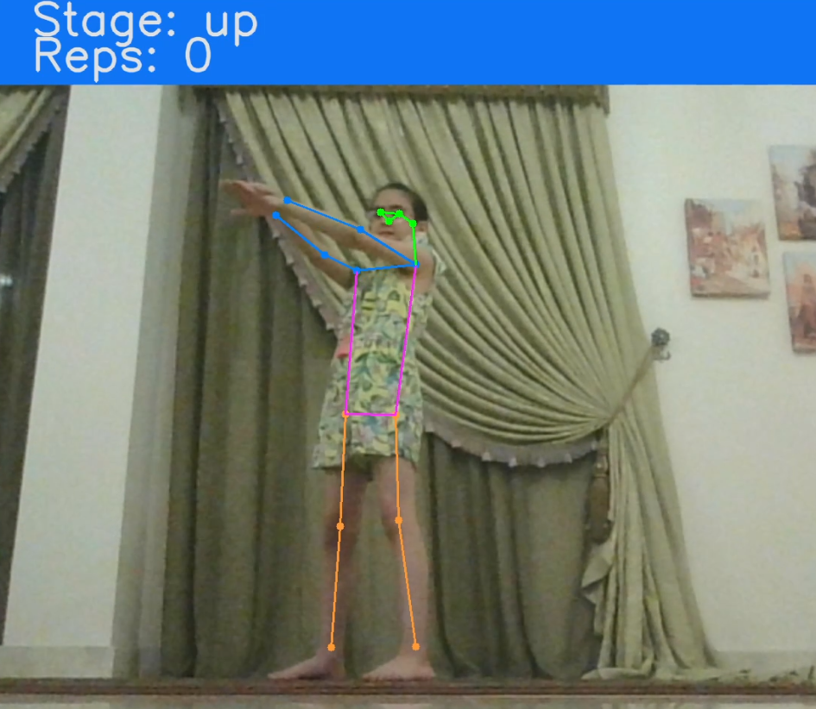

(a) (b)

Figure 29: Validating Ankle Distance

At the first Fig. (a) it shows that the distance between the ankles is not enough so, she had to widen her leg a little bit to fit the condition Fig. (b).

#### Cutting ROM of the Exercise

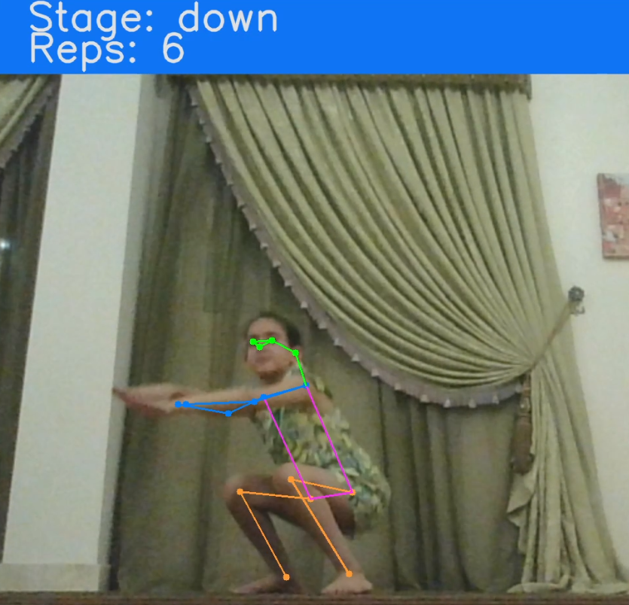

Figure 30: Cutting Biceps ROM

As said before cutting ROM of an exercise will not guarantee the trainee to reach for what he or she needs to, so it is required from the trainee to reach for the set threshold. In this case, the counter has not increased, because the trainee did not reach the required specification for completing the movement, Fig. 30.

#### Rising hips faster than chest

It is the process of bending hips before bending their knees angle, as by doing that you are putting a huge amount of load on their knees, because they must hold all your upper body weight tell you reach the proper position. By using rate of change between two variables, it can control the movement. As we can set maximum value for the difference between hip angle and knee angle, to warn the trainee to do the exercise much slower.

## Push up Exercise

### Why it is Hard to Implement Push Up Exercise using YOLOv7

It is too hard to implement push up exercise using YOLOv7 because, YOLO works in 2D, therefore some of the body parts could be difficult to be detected Fig (31). For this problem there are two solutions. the first one is to try to use another algorithm that use 3D, to get the depth of the frame and be more accurate while extracting keypoints and accurate in calculating keypoints angles, as the position of the camera will not be important to take into consideration. The second is to use multiple cameras to be able to detect body keypoints, to capture every two vectors perpendicular to them according to what exercise the trainee is doing, to get the most accurate angle calculation.

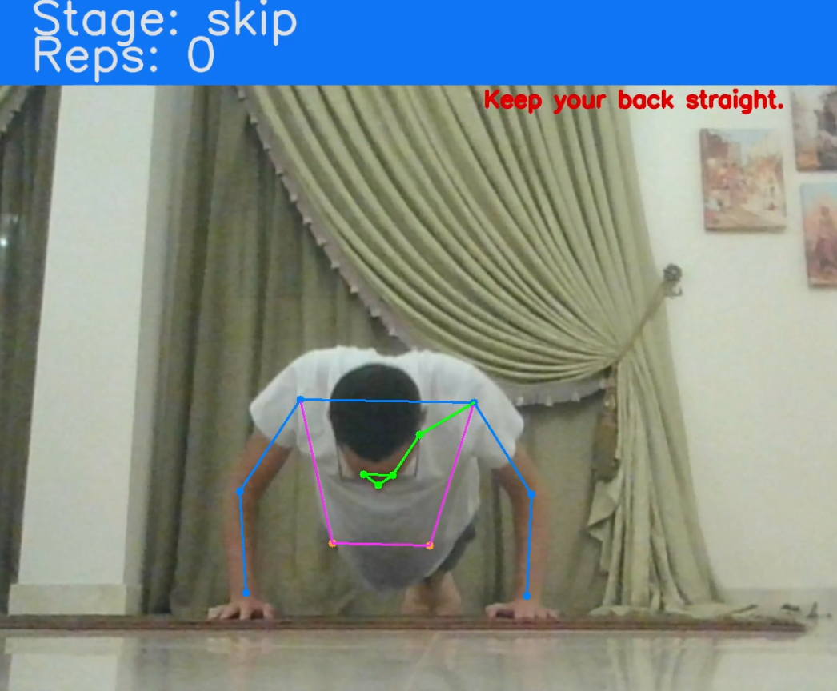

Figure 31: Limitation in Detecting Body Keypoints in 2D

# Conclusions and Future Work

## Conclusion

The main objective of this project is to develop a machine learning application using YOLOv7 and to help trainees perform the exercise in the right from. According to many professional coaches, there is no perfect form, but we are trying to increase it as much as possible to avoid injuries. Many papers have used YOLOv7 in multiple application for example yoga pose applications and motion tracking for consoles. As shown in figure 2, it shows how different approaches that models and algorithms uses to extract key-points. As explained in my paper YOLOv7 optimizes the OKS metrics where it detects the key-points as well as the bounding boxes, so there is no need to apply the grouping algorithm done in the Down-Top approach. As the key points and the bounding boxes are predicted in a single stage it does not affect the speed. What YOLO has done is to gather what is best in both approaches and present it. YOLOv7 architecture has been divided into four parts, which are Extended efficient layer aggregation network (E-ELAN), Model scaling for concatenation-based models, Planned re-parameterized convolution and Coarse for auxiliary and fine for lead loss. YOLOv7 detects the key-points of human for each frame, where it is considered as a single stage algorithm, as it tries to detect it only from the first time. Originally YOLO is an abbreviation to “you only look once.” When the application detects body key-points, according to the exercise the trainee needs the required angle will be calculated. To calculate angle between body joints using arctan2, as this equation is used to calculate angle between two vectors, as also some exercises is required to calculate distance between two points, where I have used Euclidean theorem to extract the distance. My main goal and passion are to save people from injuries, as they are doing exercises to keep fit not being in a risk of having an injury

## Future Work

One of the most important limitations faced me while implementing YOLOv7 with workout application, that YOLOv7 works in 2D only so it always sees the environment from the point of view of the camera, that will sometimes result in messing some of the key-points if it is not visible for the camera. For example, in the push up exercise its impossible to check that hips and knees angle at the angle of 180 degrees, and both elbow and shoulder angle are being bended in the proper way. There are two solutions for this problem, the first one is to try to use another algorithm that use 3D, to get the depth of the frame and be more accurate while extracting key-points and accurate in calculating key-points angles, as the position of the camera will not be important to take into consideration. The second is to use multiple cameras to be able to detect body key-points, to capture every two vectors perpendicular to them according to what exercise the trainee is doing, to get the most accurate angle calculation. Another limitation where it is required a strong GPU, where it will be hard to implement it on mobile devices. As for my future plan is to develop the application to sum up all cardio exercises and add a social platform where the trainees can communicate with many trainers, to provide them with proper diet plan to suit his body. Provide the users with a chat bot to provide him with some information and reply to the trainees with an output that suit him.

References

